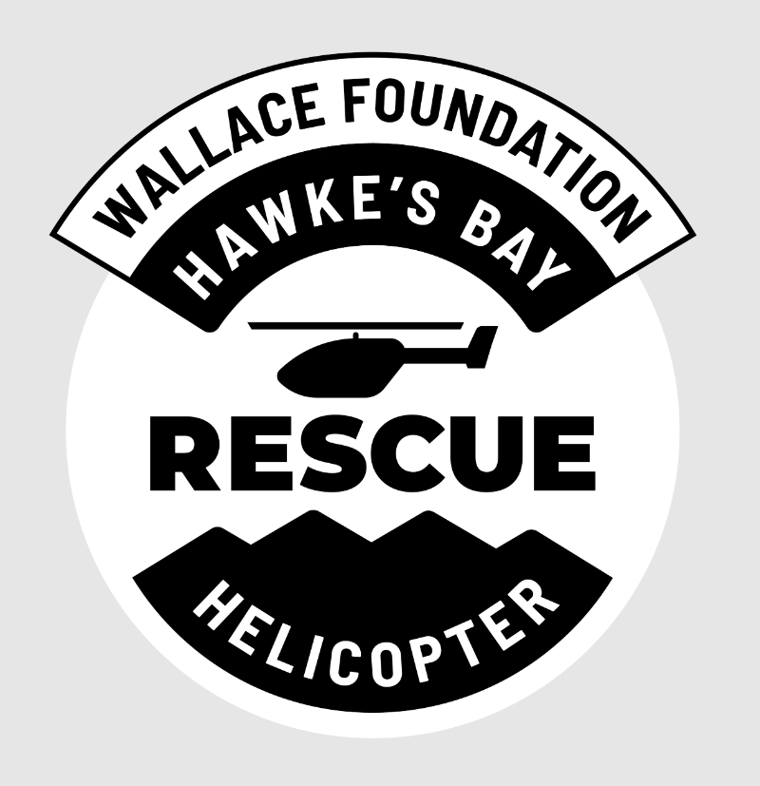
Official Release
Wallace Foundation Rescue Helicopter Brings Back Charity Auction

For immediate release: Wednesday 16th September, 2026

Hawke’s Bay’s critical air medical lifeline, the Wallace Foundation Rescue Helicopter Service, is re-launching its highly anticipated annual Charity Auction this weekend, following a several year hiatus.
The return of the auction will form the centrepiece of a new fundraising event series, ‘Off the Record’, with the inaugural event, ‘Beyond the Black Jersey’, taking place this Saturday at the Napier Conference Centre.
The evening will bring together a sell-out audience of just under 300 guests for an exclusive Q&A-style panel featuring a line-up of All Black legends, set to share candid insights into leadership, high performance, pressure and life beyond the black jersey.
The panel will serve as the curtain raiser for the evening’s feature event - the Charity Auction - with guests given the opportunity to bid on a limited range of unique experiences and items, while raising vital funds for the Wallace Foundation Rescue Helicopter Service.
For Hawke’s Bay Rescue Helicopter Trust Chief Executive Andy Quayle, the response to the inaugural event has been a strong indication of the community’s appetite to get behind the service.
“To have a sell-out crowd of just under three hundred people in the room on Saturday, with a relatively short lead-in time, has been incredibly encouraging,” Mr Quayle says.
“It demonstrates the strength of support for the rescue helicopter across Hawke’s Bay and the willingness of our corporate and community partners to get behind what is an essential regional service.
“Bringing the Charity Auction back after several years is an important milestone for the Trust. Fundraising events like this directly contribute to the sustainability of our service and our ability to be there when people need us most.”
The event’s premium auction of the evening is a luxury seven day stay for up to twelve people at The Reef House in Vanuatu, with return flights for two from Auckland flying Solomon Airlines.
The House of Travel (Hastings and Havelock North) offering came as a very pleasant surprise.
“When the team started approaching local businesses to support our charity event we were hopeful yet confident there would be solid uptake - the rescue helicopter means an awful lot to our region and everyone knows someone who maybe wouldn’t be here today without it.
“Honestly, the level of giving has been staggering, from All Blacks memorabilia to exclusive ASB Tennis Classic tickets to incredible local artwork and experiences money cannot ordinarily buy, it’s set to be a fabulous evening.”
The ‘Off the Record’ series has been developed alongside Bayleys Hawke’s Bay to provide a different style of fundraising event for the Hawke’s Bay Rescue Helicopter Trust. Designed to combine high-profile speakers and entertainment with an opportunity for guests to make a meaningful contribution to the future of the rescue helicopter service.
Bayleys Hawke’s Bay Principal James Macpherson says the inaugural theme, ‘Beyond the Black Jersey’, provides a unique opportunity to hear a different side of some of New Zealand’s most recognisable sporting figures.
“These are people who have performed at the highest level, faced enormous pressure and led teams on the world stage. Hearing their stories beyond their sporting careers gives our audience a rare insight into the people behind the jersey.
“Bayleys is proud to stand behind the Wallace Foundation Rescue Helicopter Service and can’t wait to bring this event to life. We hope people bid up large, because you just never know when you might need it.”
The return of the Charity Auction comes at an important time for the Wallace Foundation Rescue Helicopter Service, with fundraising continuing to play a critical role in supporting the operation and ensuring the service and its new H145 remains equipped to respond to emergencies across Hawke’s Bay and beyond.
The Trust says the success of Saturday’s event will help lay the foundations for future editions of the ‘Off the Record’ series.
“This is about creating an event people genuinely want to attend, while keeping the fundraising purpose front and centre,” Andy Quayle says.
“We’re incredibly grateful to everyone who has supported the event, particularly our sponsors, auction donors and guests. Their commitment allows us to continue investing in the service, ultimately, saving more lives.”
As the region's primary emergency and search and rescue air support, the Wallace Foundation Rescue Helicopter averages around 400 callouts per year and relies heavily on corporate partnership and community donations to perform each and every lifesaving mission.

ENDS.
For media enquiries or to request an interview please contact:
Alisha Neilson
Marketing and Communications Specialist
Hawke’s Bay Rescue Helicopter Trust
021 672 718
alisha@hbhrt.org.nz

